11.49: The horizontal component of the force exerted on the bar by the hinge must balance the applied force 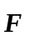, and so has magnitude 120.0 N and is to the left. Taking torques about point 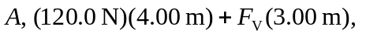so the vertical component is 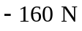, with the minus sign indicating a downward component, exerting a torque in a direction opposite that of the horizontal component. The force exerted by the bar on the hinge is equal in magnitude and opposite in direction to the force exerted by the hinge on the bar.

